Papers written by
Australian Maths Software

REVISION 2

2016

MATHEMATICS
METHODS
Units 1 & 2

Semester 2
SOLUTIONS

SECTION 1 – Calculator-free
Question 1 (6 marks)
Complete the following
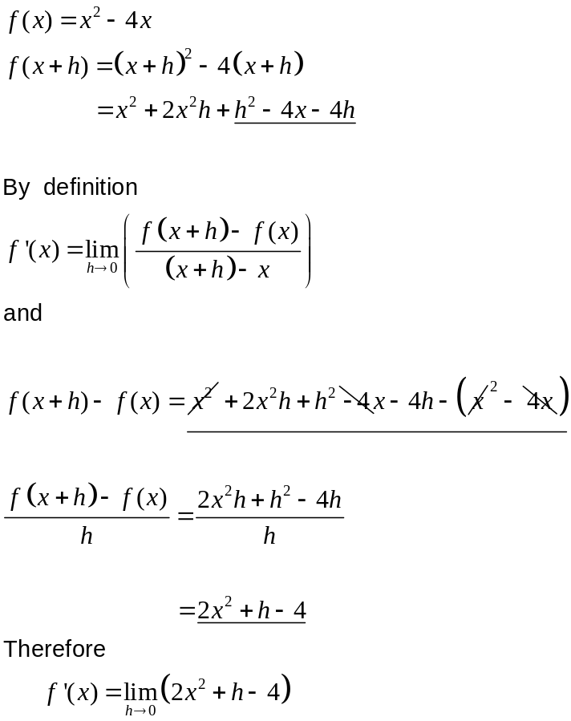
✓
✓
✓
✓
✓

∴ 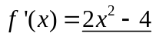
✓
Question 2 (7 marks)
(a) 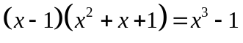
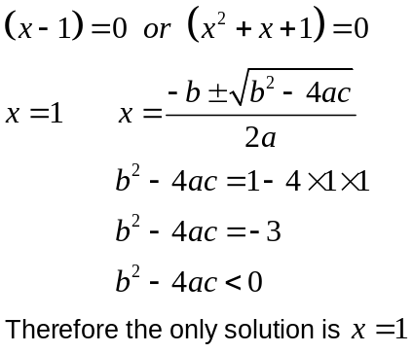
✓

✓

(b) (i) 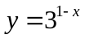
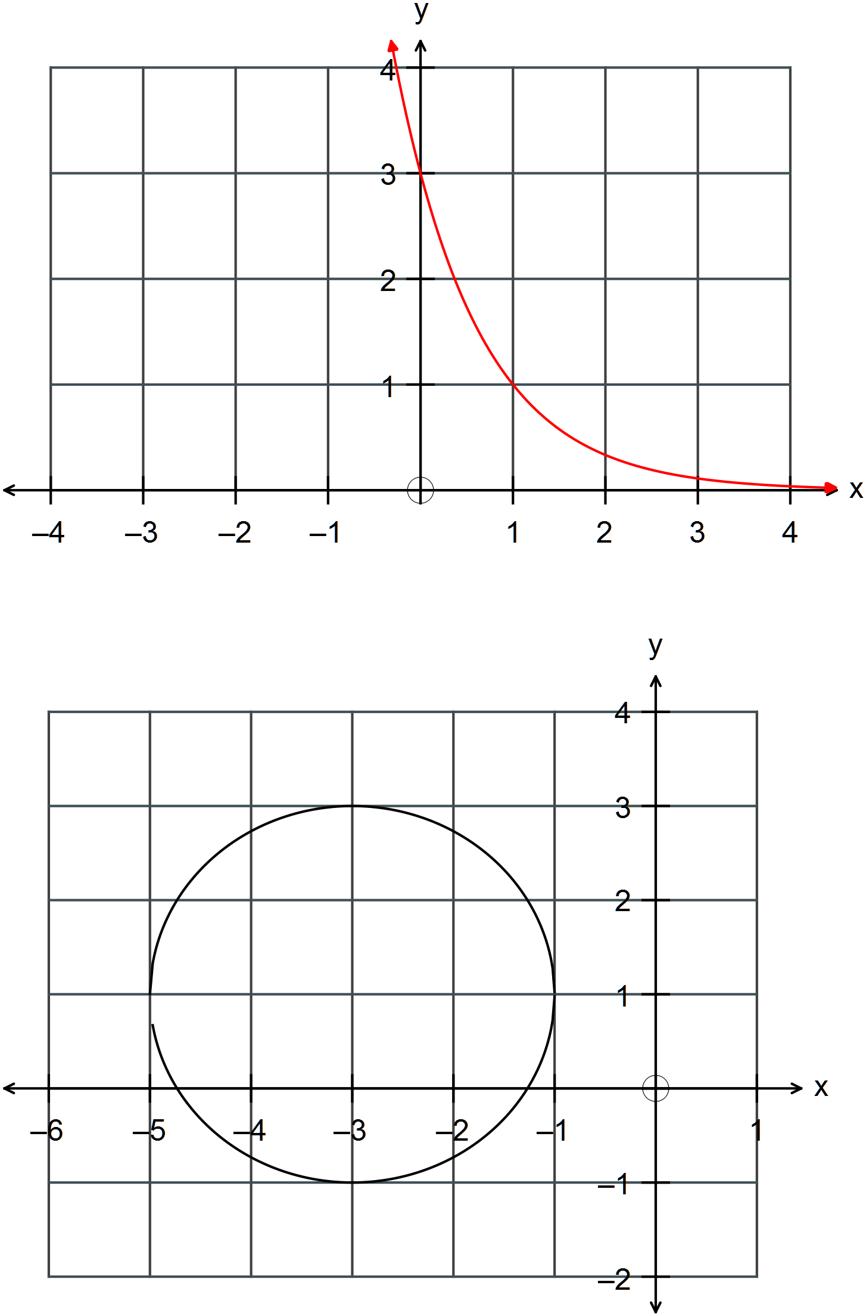
✓✓✓

✓✓

(ii) 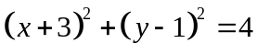

Question 3 (9 marks)
(a) 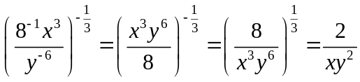
✓
✓
✓
(b) 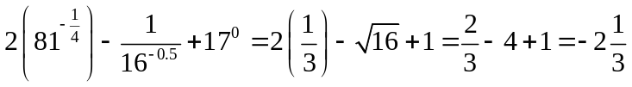
✓
✓
✓
(c) 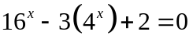
Let 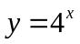
✓

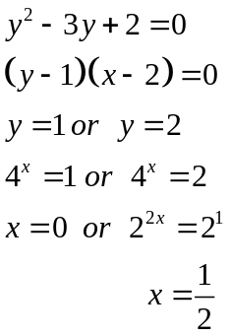
✓

✓

Question 4 (13 marks)
✓

(a) (i) 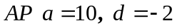
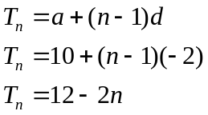
✓

(ii) 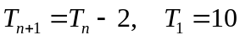 ✓✓
(b) 12, 6, 3, …..
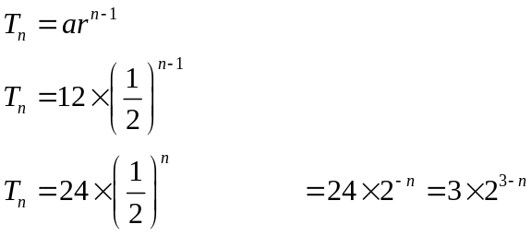
✓

✓

(c) 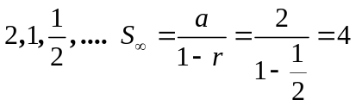
✓✓

The tree will grow to 4 metres. ✓
(d) (i) 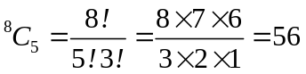 ✓✓
(ii) 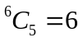 ✓✓

Question 5 (8 marks).
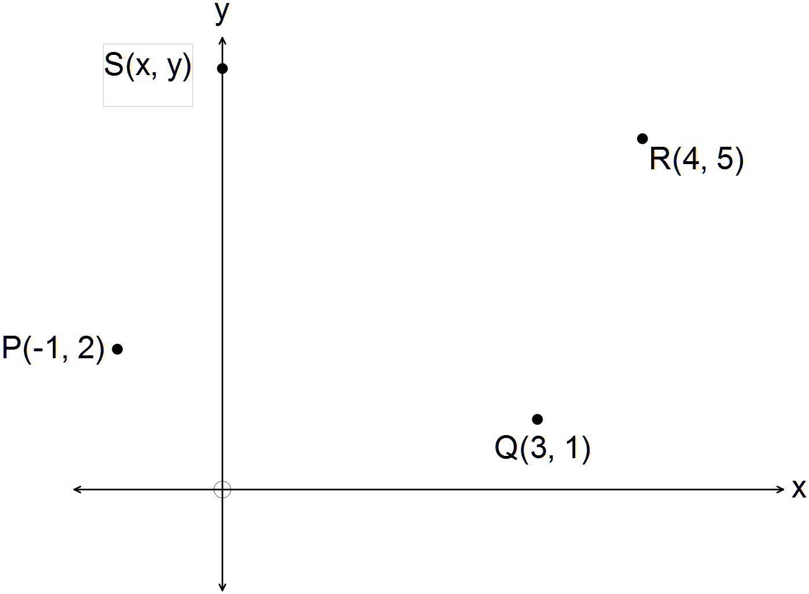

(a) (i) 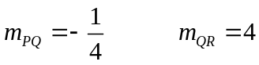
✓

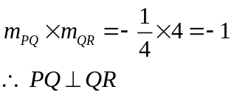
✓

(ii) 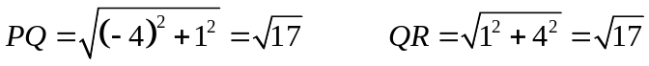
✓

✓

Therefore PQ = PR
(b)
Therefore equation of RS: 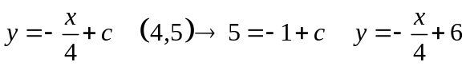
Therefore equation of PS:
✓

Find the intersection of PQ and QR:
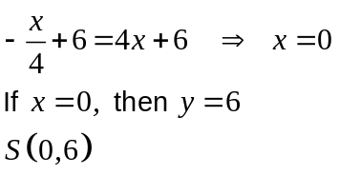
✓

(c) Midpoint of PR is 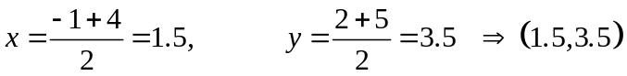
✓

Midpoint of SQ is 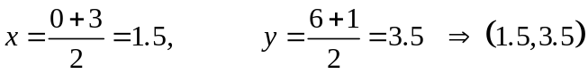
✓

The midpoints are the same.
Therefore the diagonals of the parallelogram bisect each other.

Question 6 (6 marks)
✓✓

(a) (i) 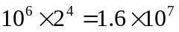
✓✓

(ii) 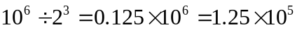
✓✓

(iii) 10.20 a.m. + 10 minutes, so 10.30 a.m.

Question 7 (12 marks)
(a) 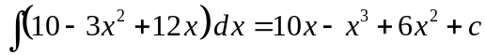
✓

(b) 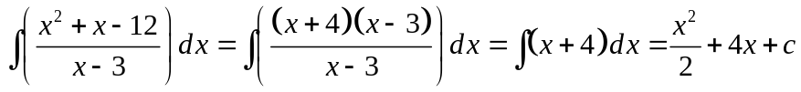
✓

✓

SECTION 2 – Calculator-assumed
Question 8 (5 marks)
✓✓

(a) (i) 60.82 m
✓

(ii) 19 m
(iii)
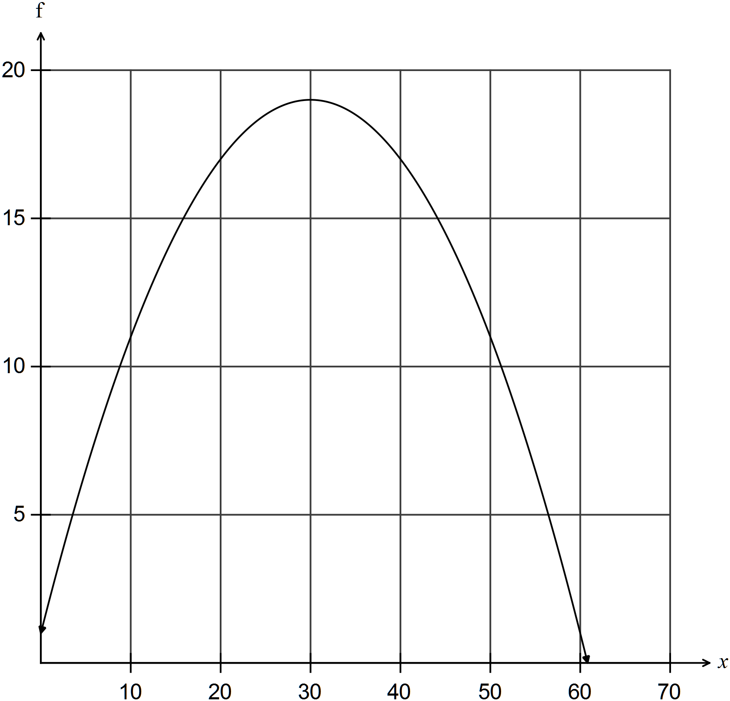
✓✓

Question 9 (10 marks)
(a)
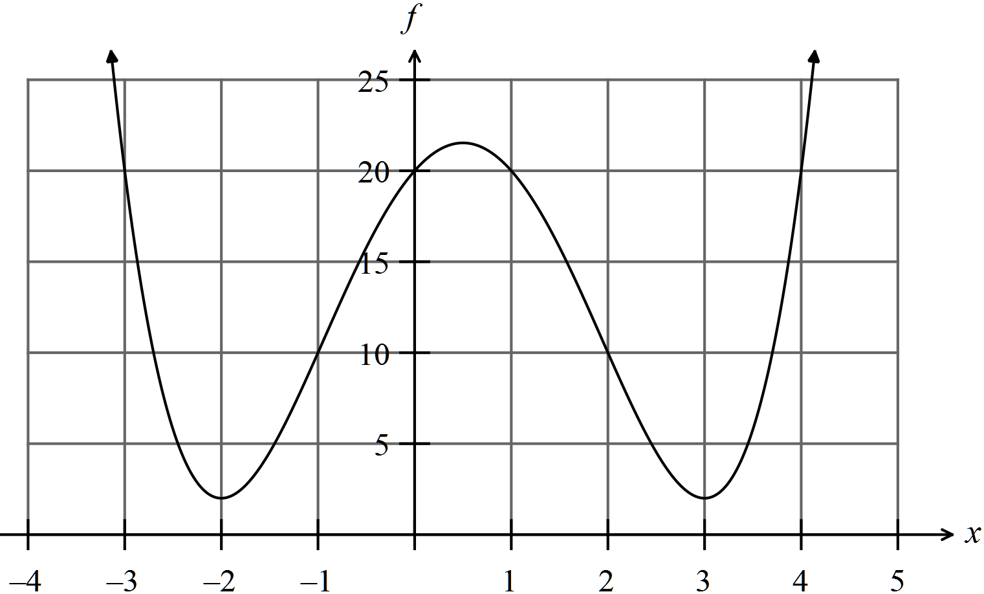
✓

✓

✓

✓

(b) (i) A(-3, 0) ✓✓
(ii) B is a maximum turning point, a local maximum and a double root where x = 0.
✓✓
(iii) 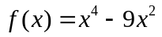
✓

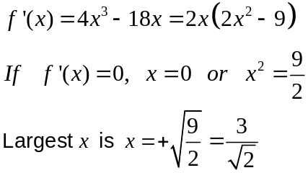 The x ordinate for C is 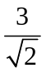. ✓

Question 10 (14 marks)
(a) 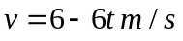
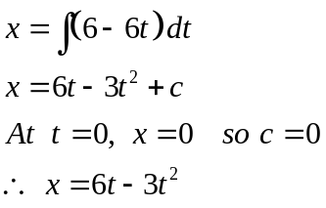
✓

✓

✓

(b) Changes direction when 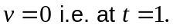 ✓✓
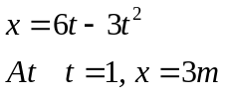 ✓✓

(c)
✓

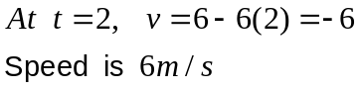
✓

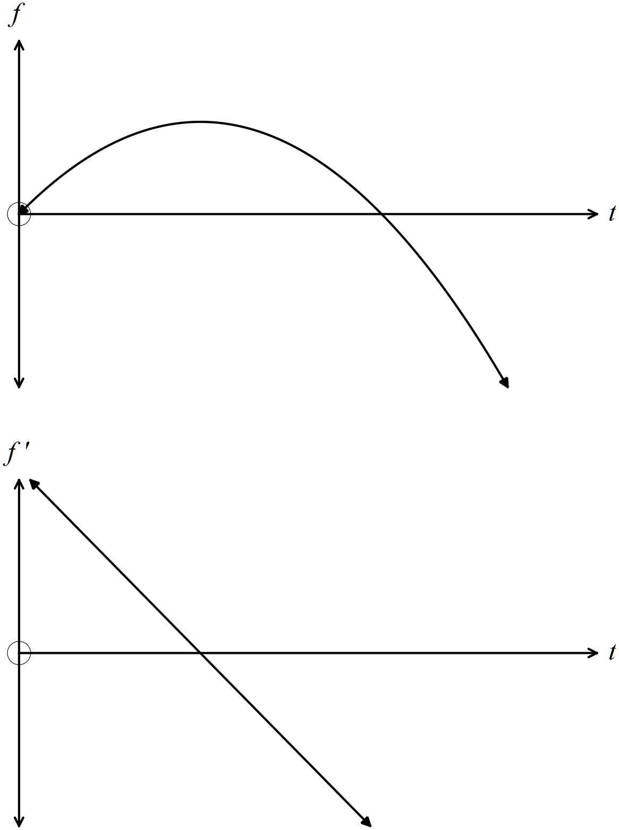 (d)

✓✓

✓✓

(e) The turning point on the displacement graph has a gradient of 0.
This corresponds to the x intercept on the velocity graph. Where the displacement is
increasing, the gradient on the velocity graph is positive and where the displacement is
decreasing, this corresponds to where the velocity graph is negative. ✓✓✓

Question 11 (6 marks)
(a) 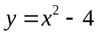
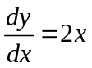 ✓
Slope of 3?
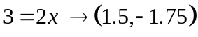
✓ ✓
(b) 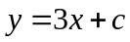
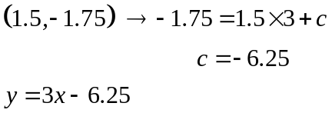
✓

✓

(c) 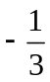
✓

Question 12 (6 marks)
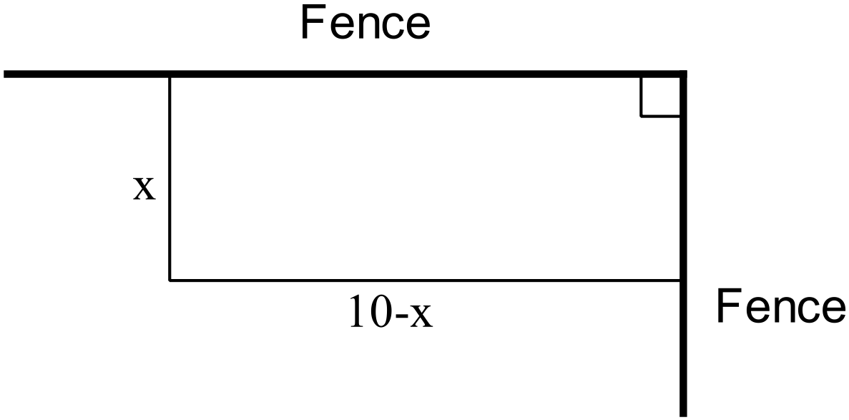


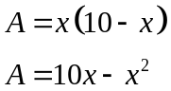
✓
For maximum area 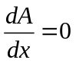
✓
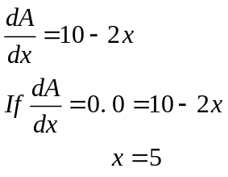
✓
✓
Test for maximum
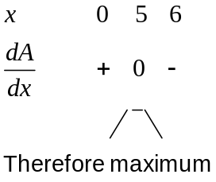
✓
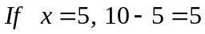
Therefore the dimensions of the maximum sized pen are 5m x 5m. ✓
Question 13 (12 marks)
(a)
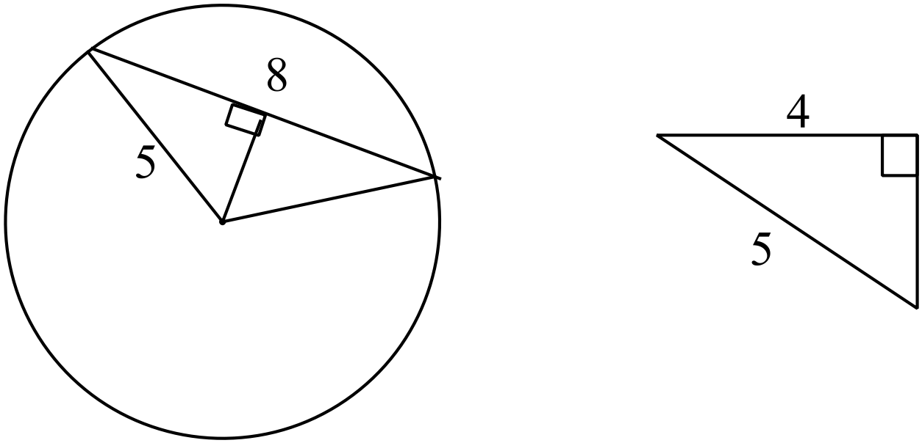
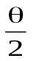
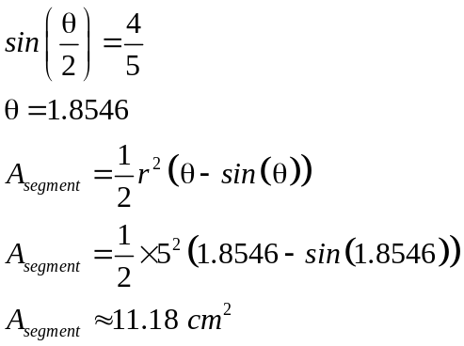
✓

✓

(b) (i) 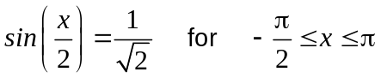
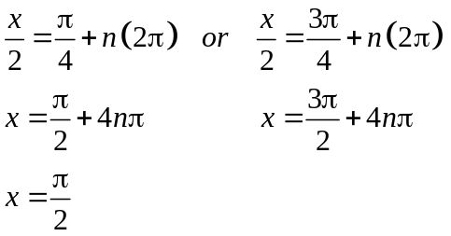
✓

✓

(ii) 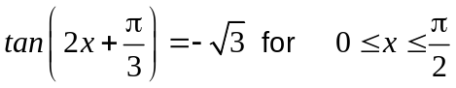
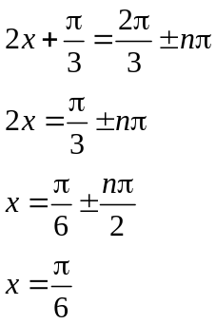
✓

✓

(c) 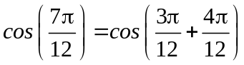
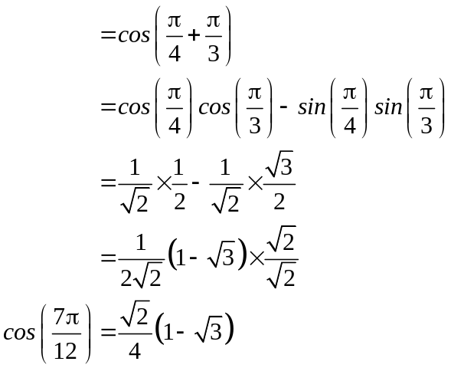
✓

✓

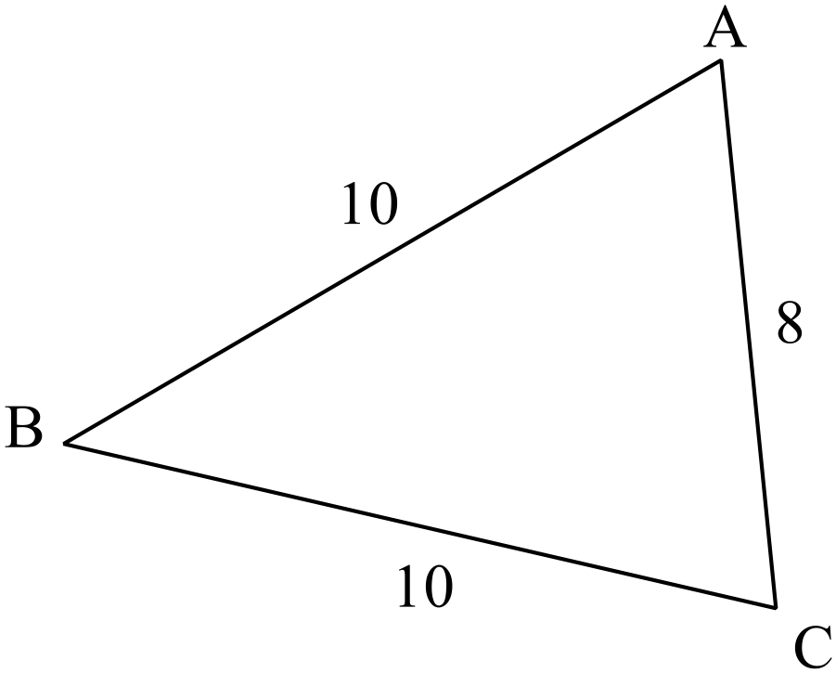(d) 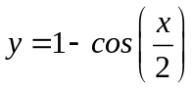
✓✓

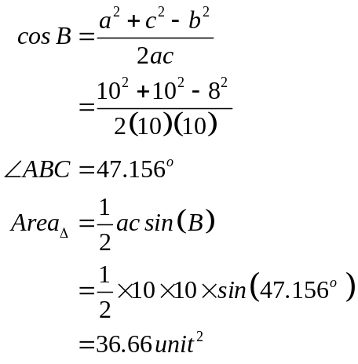(e)

✓

✓

Question 14 (19 marks)
✓

(a) (i) 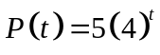
✓

(ii) 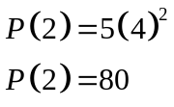
✓

(iii) 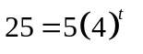
✓

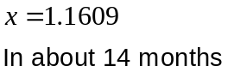
✓

(b) 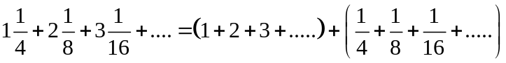
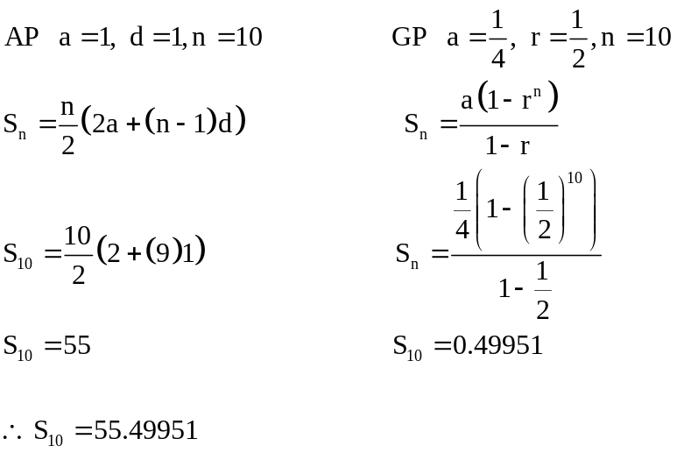
✓

✓

✓

✓

✓

Question 15 (4 marks)
(a) (i) 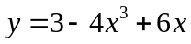
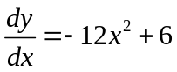
✓✓

✓

(ii) 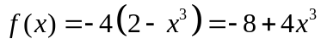
✓

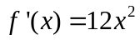

Question 16 (9 marks)
✓

(a) (i) 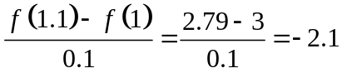
✓

✓

✓✓

(ii) You have found the gradient of the interval from x = 1 to x = 1,1
which is an approximation to the slope at x = 1.

(iii) The average rate of change is the gradient of an interval. ✓
The instantaneous rate of change is the slope at a point which is the same
as the slope of the tangent at that point. ✓

(b) The area is effectively the product of velocity and time and gives the displacement.
✓✓

Question 17 (11 marks)
(a) (i) 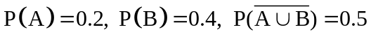
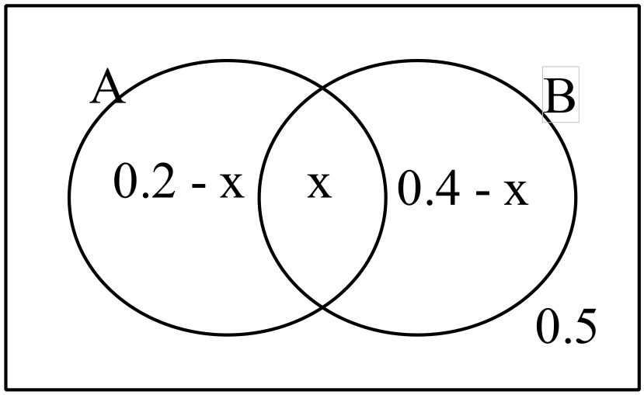
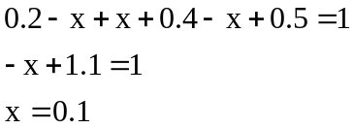
✓

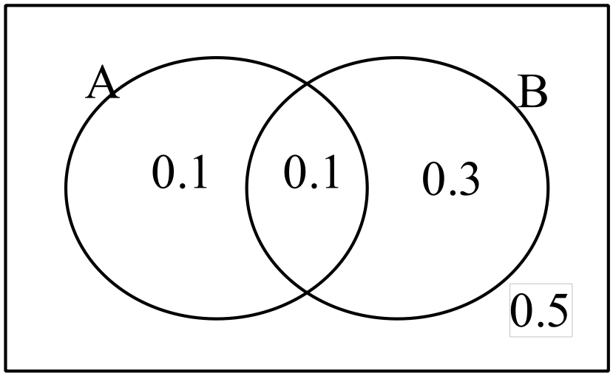
✓

If events A and B are independent, then 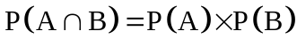
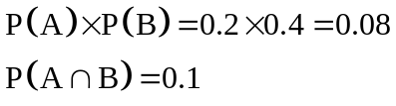
✓

Therefore events A and B are NOT independent.

(ii) If events A and B are mutually exclusive, then 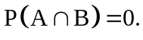
✓

But 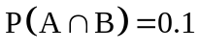 so events A and B are NOT mutually exclusive.

(b) 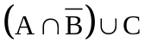

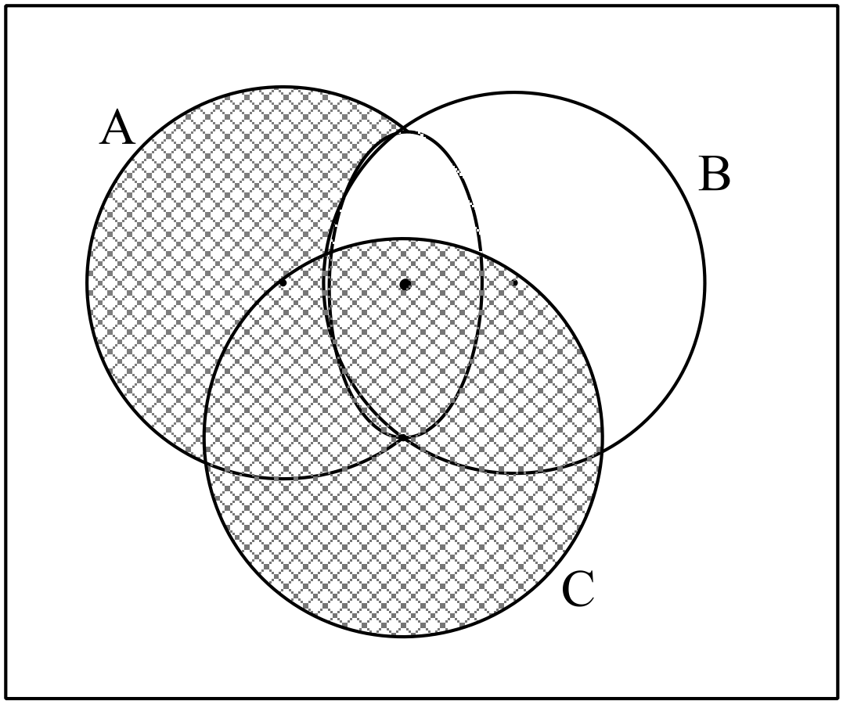
✓✓

(c) (i)
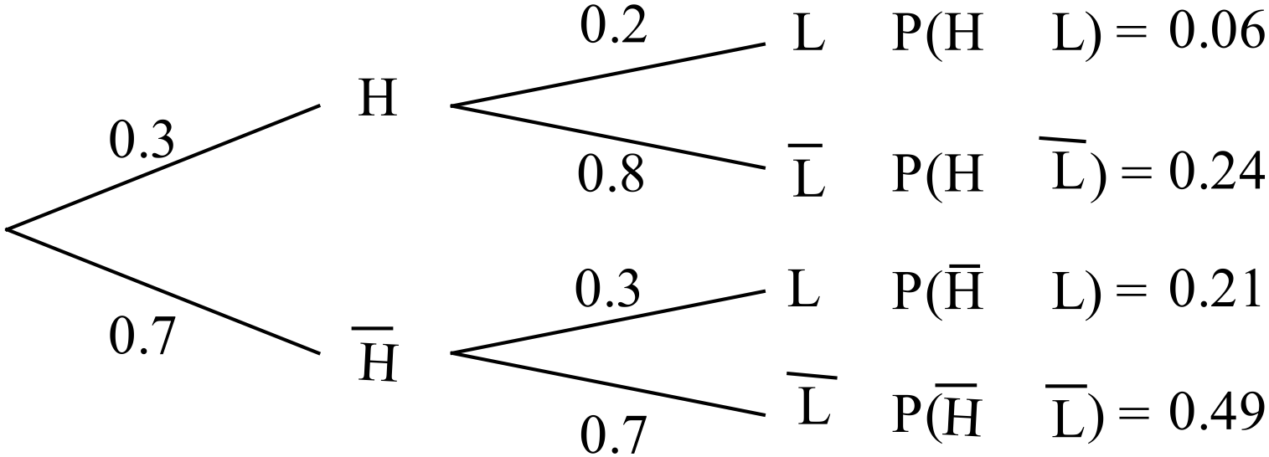
✓✓

(ii) 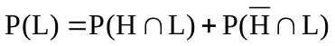
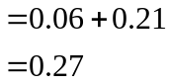
✓

(iii) 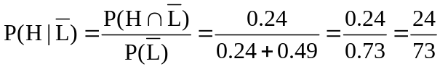
✓

✓

Question 18 (11 marks)
✓

(a) 5, 7 ,9 AP a = 5, d = 2
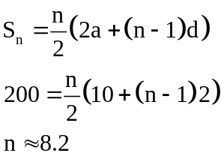
✓

✓✓

✓

“At least” implies Ruth would need to go out and drive 9 times.
(b) 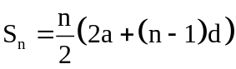
✓

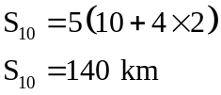
✓✓

(c) 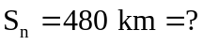
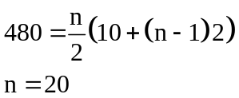
✓

✓✓

Ruth took 20 lessons!
End of solutions

